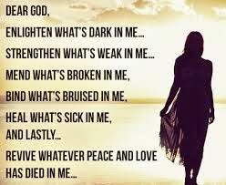
Self-analysis discovery……….

What’s dark in you?
What’s weak in you?
What’s broke in you?
What’s bruised in you?
What needs to be healed?
What has died in you?

